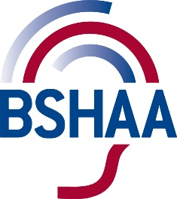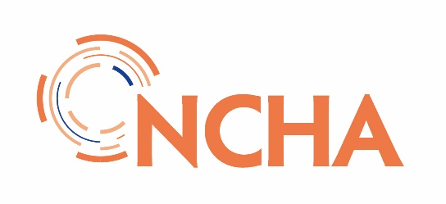
To whom it may concern
JCVI COVID-19 VACCINATON PROGRAMME - HEALTHCARE WORKER IN PRIORITY GROUP 2
Community based audiology staff are included in priority group 2 for receiving the Covid-19 vaccine under the Joint Committee on Vaccination and Immunisation’s (JCVI) definition of frontline healthcare staff and prioritisation schedule.
This letter confirms that the following person is eligible for vaccination as a healthcare worker in priority group 2.
Locum/self-employed member details
Click or tap here to enter text.
and is classified as
☐ Staff involved in direct patient care
☐ Non-clinical staff in community healthcare settings
Practice details
I am based at:
Click or tap here to enter text.

Yours sincerely
Click or tap here to enter text.
Contact details: Click or tap here to enter text.

UK wide JCVI definitions of healthcare staff This includes staff who have frequent face-to-face clinical contact with patients and who are directly involved in patient care in either secondary or primary care/community settings. This includes doctors, dentists, midwives and nurses, paramedics and ambulance drivers, pharmacists, optometrists, occupational therapists, physiotherapists and radiographers. It should also include those working in independent, voluntary and non-standard healthcare settings such as hospices, and community-based mental health or addiction services. Temporary staff, including those working in the COVID-19 vaccination programme, students, trainees and volunteers who are working with patients must also be included.
This includes non-clinical ancillary staff who may have social contact with patients but are not directly involved in patient care. This group includes receptionists, ward clerks, porters and cleaners. Source: Covid-19 green book This letter is supported by UK wide audiology professional associations. The Association of Independent Hearing Healthcare Professionals (AIHHP), British Society of Hearing Aid Audiologists (BSHAA) and the National Community Hearing Association (BSHAA)

